Title: Systemic therapy as First-Line Treatment for Patients with Metastatic Colorectal Cancer: A Systematic Review and Network meta-analysis of Randomized Clinical Trials

sTable 1: Literature Search Strategy (July 15, 2019)
Embase | CENTRAL | Medline
1 ((colon cancer) or colorectal)/ | 1 ((colon cancer) or colorectal)/ | 1 ((colon cancer) or colorectal)/
2 (Advance* or metastatic).mp. | 2 (Advance* or metastatic).mp. | 2 (Advance* or metastatic).mp.
3 (FOLFOX or CAPEOX).mp. | 3 (FOLFOX or CAPEOX).mp. | 3 (FOLFOX or CAPEOX).mp.
4 Bevacizumab.mp. | 4 Bevacizumab.mp. | 4 Bevacizumab.mp.
5 Irinotecan.mp. | 5 Irinotecan.mp. | 5 Irinotecan.mp.
6 Cetuximab.mp. | 6 Cetuximab.mp. | 6 Cetuximab.mp.
7 Panitumumab.mp. | 7 Panitumumab.mp. | 7 Panitumumab.mp.
8 Dabrafenib.mp. | 8 Dabrafenib.mp. | 8 Dabrafenib.mp.
9 Trametinib.mp. | 9 Trametinib.mp. | 9 Trametinib.mp.
10 Dabrafenib.mp. | 10 Dabrafenib.mp. | 10 Dabrafenib.mp.
11 Nivolumab.mp. | 11 Nivolumab.mp. | 11 Nivolumab.mp.
12 Ipilimumab.mp. | 12 Ipilimumab.mp. | 12 Ipilimumab.mp.
13 Trastuzumab.mp. | 13 Trastuzumab.mp. | 13 Trastuzumab.mp.
14 Regorafenib.mp. | 14 Regorafenib.mp. | 14 Regorafenib.mp.
15 Lapatinib.mp. | 15 Lapatinib.mp. | 15 Lapatinib.mp.
16 Oxaliplatin.mp. | 16 Oxaliplatin.mp. | 16 Oxaliplatin.mp.
17Ziv-aflibercept.mp. | 17Ziv-aflibercept.mp. | 17Ziv-aflibercept.mp.
18 Ramucirumab.mp. | 18 Ramucirumab.mp. | 18 Ramucirumab.mp.
19 (Leucovorin or 5-FU).mp. | 19 (Leucovorin or 5-FU).mp. | 19 (Leucovorin or 5-FU).mp.
20 Pertuzumab.ti. | 20 Pertuzumab.ti. | 20 Pertuzumab.ti.
21 Placebo.ti. | 21 Placebo.ti. | 21 Placebo.ti.
22 or 4-21 | 22 or 4-21 | 22 or 4-21
23 (immunotherapy or targeted therapy).mp. | 23 (immunotherapy or targeted therapy).mp. | 23 (immunotherapy or targeted therapy).mp.
24 Inhibit*.mp. | 24 Inhibit*.mp. | 24 Inhibit*.mp.
25 (Pembrolizumab or binimetinib).mp. | 25 (Pembrolizumab or binimetinib).mp. | 25 (Pembrolizumab or binimetinib).mp.
26 Capecitabine.mp. | 26 Capecitabine.mp. | 26 Capecitabine.mp.
27 Tipiracil.mp. | 27 Tipiracil.mp. | 27 Tipiracil.mp.
28 Trifluridine.mp. | 28 Trifluridine.mp. | 28 Trifluridine.mp.
29 vemurafenib.mp. | 29 vemurafenib.mp. | 29 vemurafenib.mp.

sFigure1: Study selection
Records excluded
(n = 109)
Records screened
(n = 162)
Records after duplicates removed
(n = 162)

Identification

Eligibility

Included

Screening

Additional records identified through other sources
(n = 0 )
Records identified through database searching
(n = 557)

Full-text articles excluded, with reasons
(n = 23)
Full-text articles assessed for eligibility
(n = 53)

Studies included in qualitative synthesis
(n = 30)

Studies included in quantitative synthesis (meta-analysis)
(n = 30)

sFigure2: Network diagram for each outcome
2.A Overall survival

2.B Progression-free survival

2.C Serious adverse events

sFigure3 Risk of bias assessment of included studies
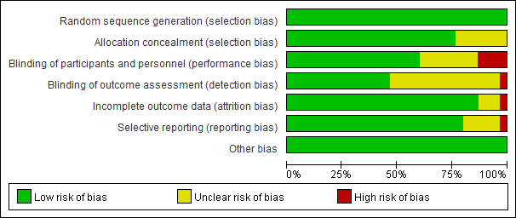
A: review authors’ judgments about each risk of bias item presented as percentages across all included studies.
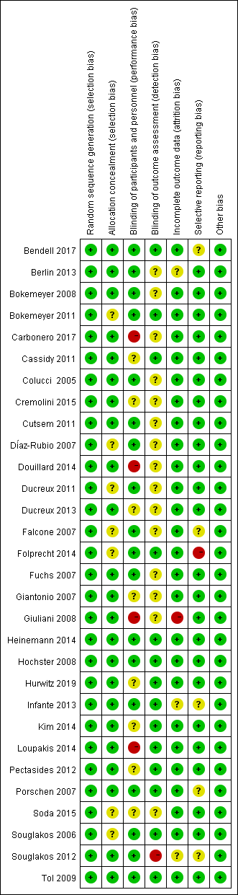
B: Risk of bias assessment of included studies

sFigure4: The SUCRA plot of each treatment
4.A Overall survival
4.B Progression-free survival
4.C Serious adverse events
A: FOLFOX/Bev; B: CapeOx/Bev; C: FOLFOX; D: CapeOX; E: FOLFIRI/Bev; F: FOLFOXIRI/Bev; G: FOLFIRI; H: XELIRI/Bev; J: Bev; K: FOLFIRI/Cetuximab; L: FOLFOX/Cetuximab; M: CapeOx/Bev/Cetuximab; N: FOLFOX/panitumumab; O: FOLFOXIRI; P: FUOX; Q: FUFOX;R: XELIRI; S: FOLFOX/Bev/Vismodegib; T: FOLFIRI/bev/Vismodegib; U: FOLFOX/Axitinib; V: FOLFOX/Axitinib/Bev; W: FOLFOX/Bev/Onartuzumab: X: FOLFOX/bevacizumab/parsatuzumab; Y:CapeOX/SOX; Z: CapeOX/Cetuximab.

sTable 2: Surface under the cumulating ranking curve (SUCRA) data for all outcomes
A. SUCRA rankings for overall survival
FOLFOXIRI/Bev | 77.2
FOLFOX/Bev | 77.1
CapeOX/SOX | 76.6
CapeOx/Bev | 68.5
XELIRI/Bev | 68.1
FOLFIRI/Bev | 68.0
FOLFOX/Axitinib/Bev | 65.6
FOLFOX/Axitinib | 62.8
FOLFOX/bevacizumab/parsatuzumab | 62.3
FOLFOXIRI | 53.3
CapeOX | 52.7
CapeOx/Bev/Cetuximab | 48.6
Bev | 44.5
FOLFOX | 43.8
FOLFOX/Axitinib/Bev | 42.3
FOLFIRI/Cetuximab | 41.3
FUFOX | 36.2
FOLFIRI/Cetuximab | 35.4
FUOX | 27.7
FOLFIRI | 22.4
FOLFOX/panitumumab | 22.2

B. SUCRA rankings for progression-free survival
FOLFOXIRI/Bev | 93.2
FOLFOXIRI | 79.9
FOLFOX/Bev/parsatuzumab | 79.5
XELIRI/Bev | 76.5
FOLFIRI/Bev | 75.0
CapeOX | 71.7
FOLFOX/Bev | 73.5
FOLFIRI/Cetuximab | 69.1
FOLFOX/Cetuximab | 63.0
FOLFIRI/bev/Vismodegib | 59.3
FOLFOX/Axitinib/Bev | 58.3
CapeOX/SOX | 54.1
FOLFIRI | 52.6
FOLFOX | 48.0
CapeOx/Cetuximab | 46.0
CapeOx/Bev | 45.8
FOLFOX/Bev/Onartuzumab | 45.1
FOLFOX/Axitinib | 35.5
CapeOX | 32.6
FOLFOX/panitumumab | 27.3
CapeOx/Bev/Cetuximab | 27.2
Bev | 21.7
FUOX | 20.5
FUFOX | 20.2
CapeOx/Cetuximab | 17.2

C. SUCRA rankings for adverse events
FOLFOXIRI/Bev | 96.3
XELIRI/Bev | 83
CapeOX | 76.7
FOLFOX | 76
FOLFOX/Axitinib/Bev | 75.7
CapeOx/Bev | 65.4
FOLFIRI/Bev | 53.8
Bev | 50
FOLFIRI/Cetuximab | 49.9
FOLFIRI | 49.8
FOLFOX/Bev/Vismodegib | 49
FOLFOX/Bev | 44
FOLFOX/panitumumab | 43.5
CapeOx/Bev/Cetuximab | 37.5
FOLFOX/Cetuximab | 33.1
FOLFOXIRI | 27.9
FOLFOX/Axitinib | 18.7
FOLFIRI/bev/Vismodegib | 14.5
FOLFOX/Bev/Onartuzumab | 4.6
SUCRA=Surface under cumulative ranking curve,

